**MINI PROJECT**

**(2020-201)**

**RESTAURANT MANAGEMENT SYSTEM**

**MID-TERM REPORT**



**Department of Computer Engineering & Applications**

**Submitted by-**

1) Pranjal Singh (181500479) 2) Khalid Ansari (181500322)

3) Sanjesh Kumar (181500620) 4) Neelanshu Singh (181500419)

5) Vaibhav Pratap Singh (I – 58 / 18150077500)

**Supervised By: -**

**Ms. Priyanka Gupta**

**Technical Trainer**

**Department of Computer Engineering & Applications**

**Contents**

**Abstract 3**

**1. Introduction 4**

1.1 General Introduction to the topic 4

1.2 Area of Computer Science 5

1.3 Hardware and Software Requirements6

**2. Problem definition 7**

**3. Objectives 8**

**4. Implementation Details 11**

**5. Progress till Date & the Remaining work 11**

**6. Some Screenshots 12**

**7. References 13**

**Abstract**

Restaurant Management System is a web application to restaurant management in an ease way.

This system wake to provide a better service facility to restaurant and also to the customer. The

Online system provide facility like food ordering and table reservation management by the

Customer through online system, customer login and information management, menu

Management, admin login and view all orders. Admin here can add food items to the restaurant

List and view all table reservation and food orders by customers. With this online web application

Food ordering and table reservation management it become easier to replace the traditional system

Which even difficult to store the records for long period of time. We are using the method of

Prototyping model during the development of Restaurant Management System.

This system entirely reduces the unnecessary time. Items can also easily be shared by the whole

Table, moved or modified, and noted and the cost can be calculated in real time. It makes it easier

For the customer to build his/her order and also view the most popular dishes.

**Introduction**

* 1. **General Introduction to the topic**

In Restaurant Management online system, we’ll learn the systematic process of running a

Restaurant—by ease into ordering food. This web application; managing food item list; food

Safety and hygiene; customer relations; marketing; using a point-of-sale system; scheduling

Reservation of table efficiently; and dealing with guests enthusiasm.

Restaurant Management will prepare you for a steady business career, whether you plan to arrange a fast food franchise, operate a casual sit-down restaurant, or oversee a fine-dining establishment.

**About Restaurant Management System:**

• To develop android application for restaurant ordering system and provides facility to update the menu. .

• To develop a software at kitchen and cashier to receive order from server.

• To establish network for kitchen, cashier and android device and print the bill at customer side.

• Customer should be able to enter the feedback about the service and the food served by restaurant android application.

**What Restaurant Management System is:**

The Restaurant Management System helps the restaurant manager to manage the restaurant more

Effectively and efficiently by computerizing meal ordering, billing and inventory control. This

Management system is designed for serving a food with love.

The system processes transaction and stores the resulting data. Reports will be generated from

These data which help the manager to make appropriate business decisions for the restaurant. For

Example, knowing the number of customers for a particular time interval, the manager can

Decide whether more waiters and chefs are required or to expand the business.

**Area of Computer Science:**

This web application; managing food item list; food Safety and hygiene; customer relations; marketing; using a point-of-sale system; scheduling.

Reservation of table efficiently; and dealing guests with enthusiasm. With this online web application

Food ordering and table reservation management it become easier to replace the traditional system

Which even difficult to store the records for long period of time

1.3 Hardware Requirements

• Memory [4GB RAM (or higher)]

• Intel core i3 – 8th Gen 64-bit Processor (or higher)

**1.3 Software requirements**

• Xampp server

• Visual Studio Code

• MySQL Databases

**Objective**

The main objectives of the creating the Restaurant Management System to the build

The system this is to provide ordering and reservation service by online to the customer. The

Main point of developing this system is to help restaurant administrator management.

The restaurant business and help customer for online ordering and reserve table. To manage the

Restaurant more effectively and efficiently by computerizing meal ordering, billing and table

Reservation. It combines all the necessary functionality under the one roof with tools to

Manage the orders, reservations and calculation.

**Implementation Details**

**Part 1:** To build the Restaurant Management System.

With the use of Visual studio code, we created a web application. Now with the help of

Xampp server open web application in your browser now we have to create an a customer

Registration.

By filling details like name, e-mail id, Password and phone number one can create the

Sign in into the system.

**Part 2:** Then login into the system by further input the credentials.

**Part 3:** Then select food whichever you like by simply clicking on the icon of the food item.

**Part 4:** After that move ahead towards the cart and select quantity and pay book your order.

**Part 5:** Finally order will be booked successfully.

**Progress till Date & The Remaining work**

* We have successfully create header which contains the navigation bar.
* Basket cart is completed for checkout balance.
* Menu part is completed to select the food items.
* Details part which describe about the food item is partially completed.
* We now have to include the admin section.

In this it will add food item, update it and views order details.

* CSS part to implement and attractive looking view of application.
* Reservation section to order the table.
* Process order section to include it into the database further.
* JavaScript interactive behavior to web pages.

**SCREENSHOTS**

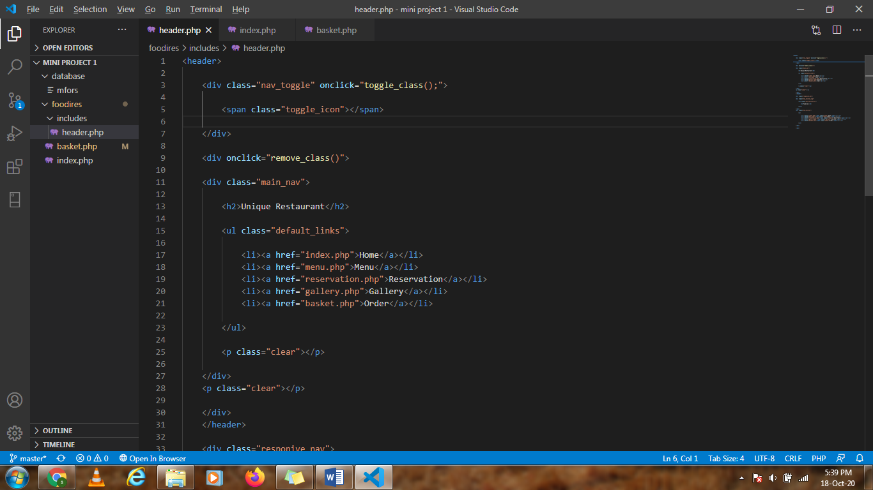

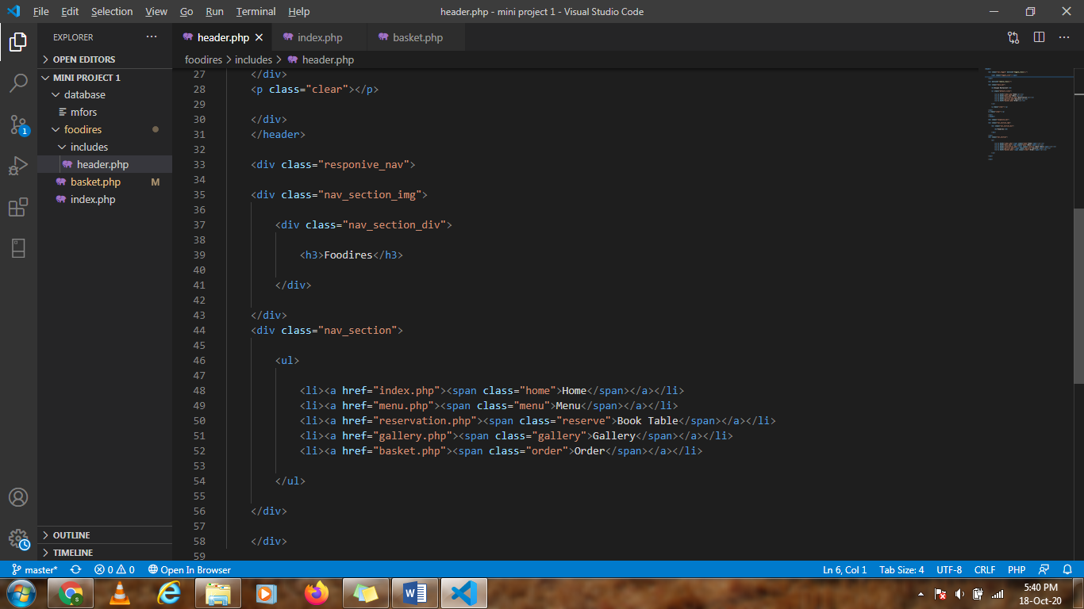

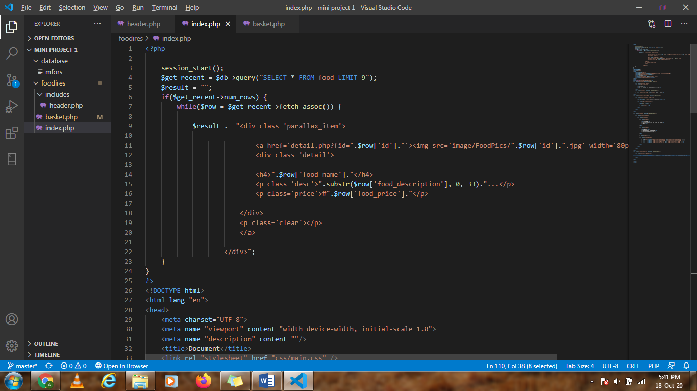

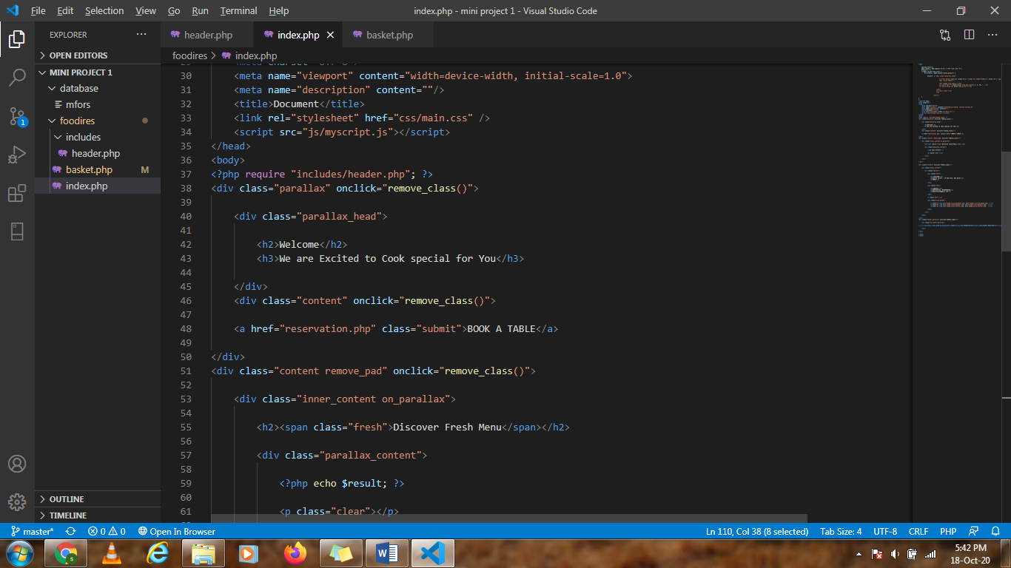

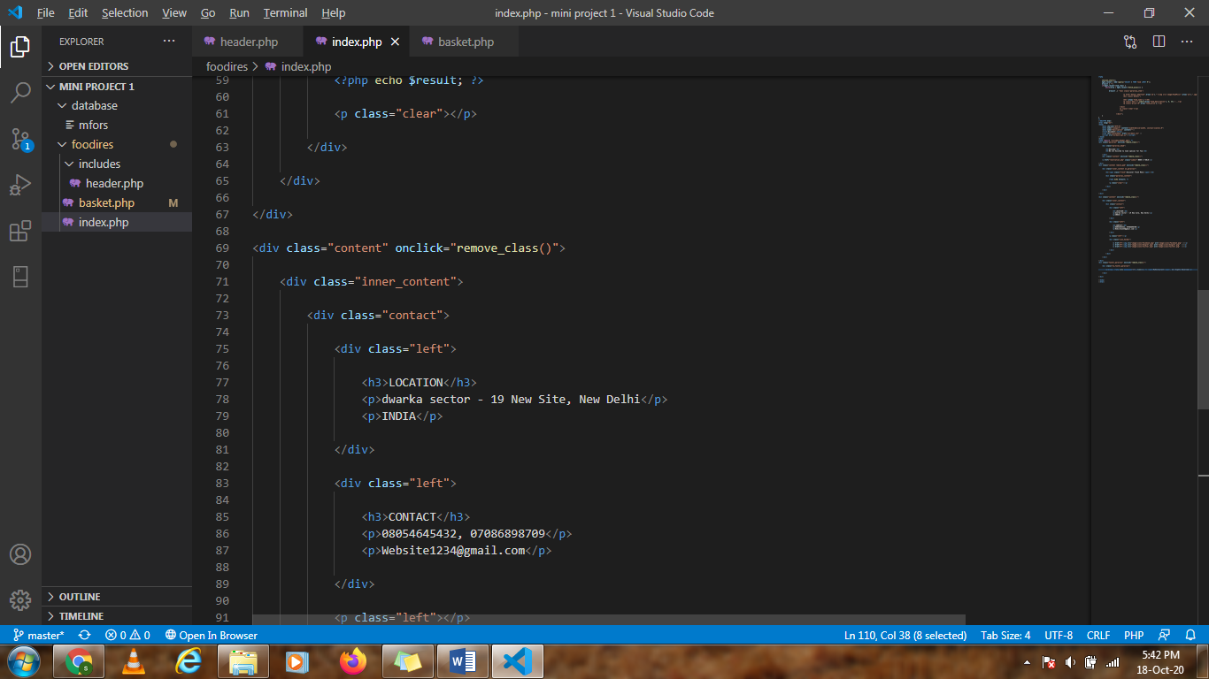

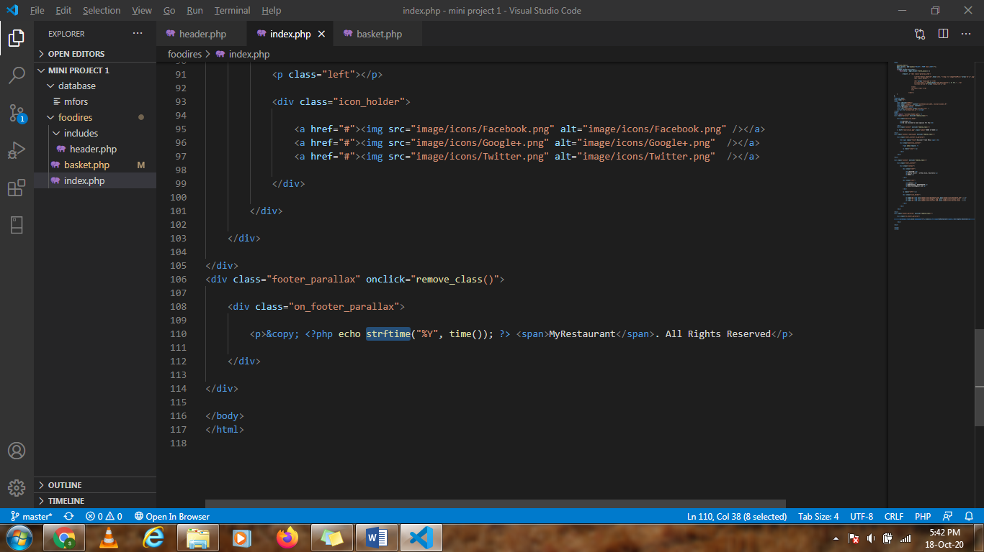

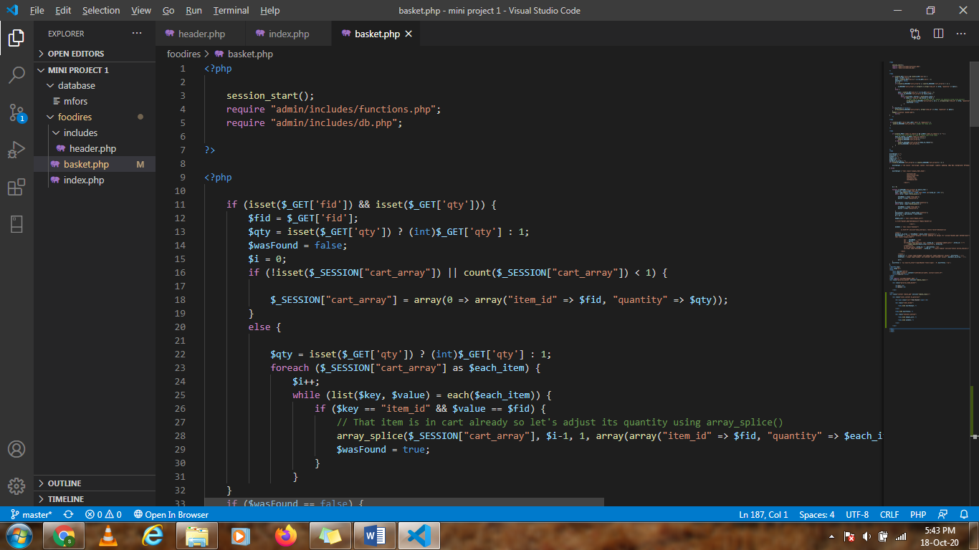

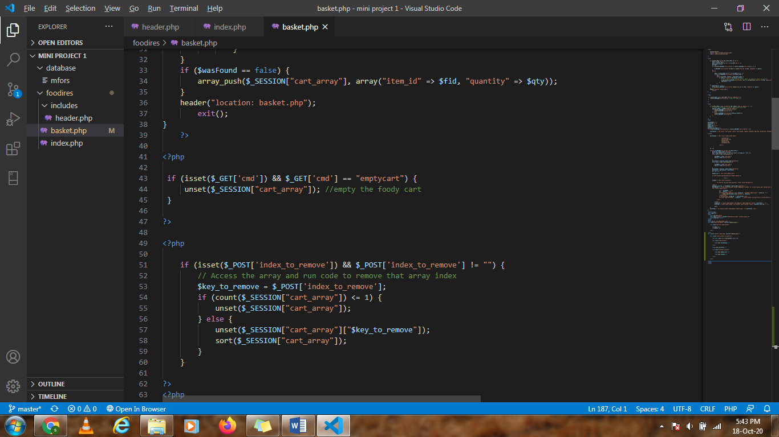

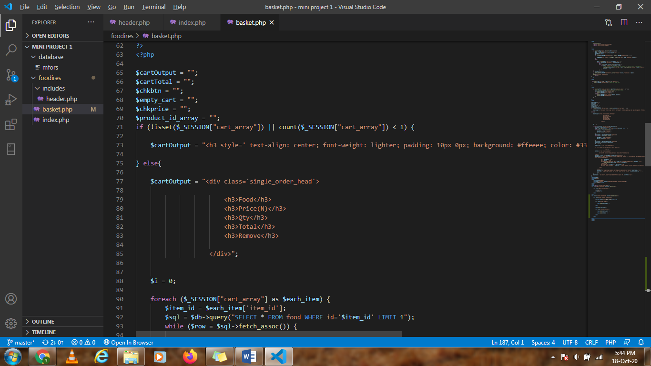

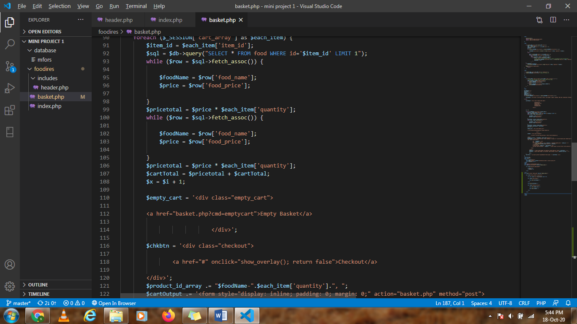

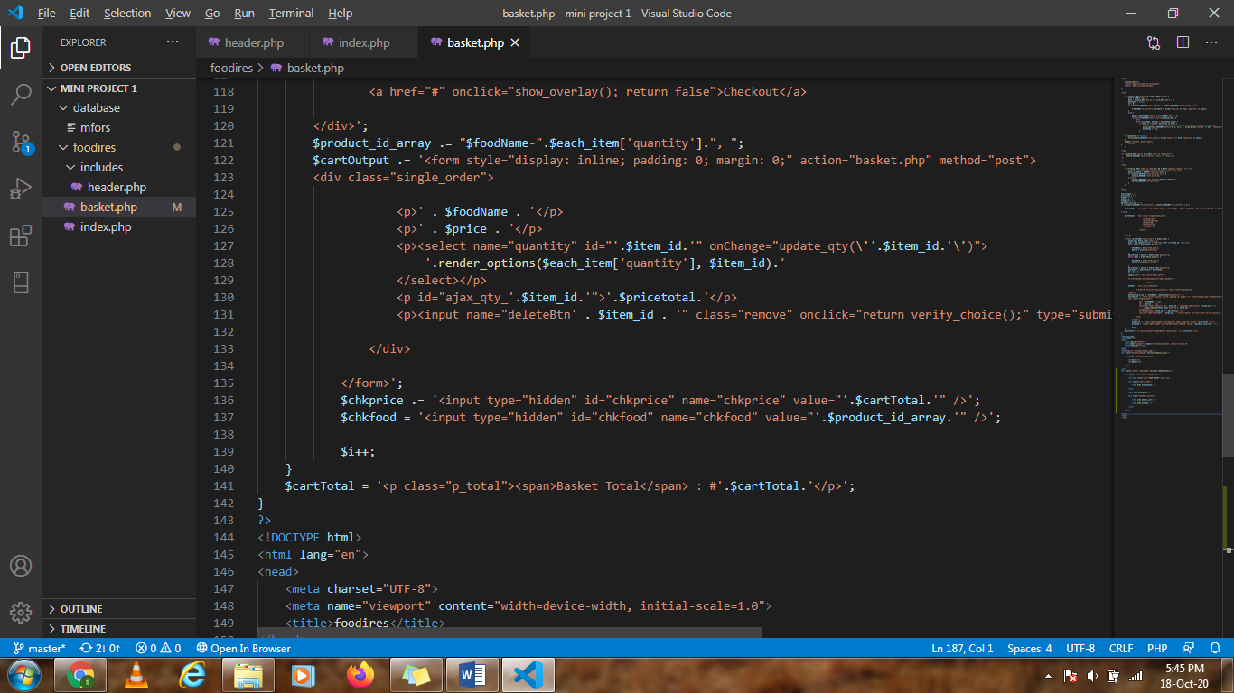

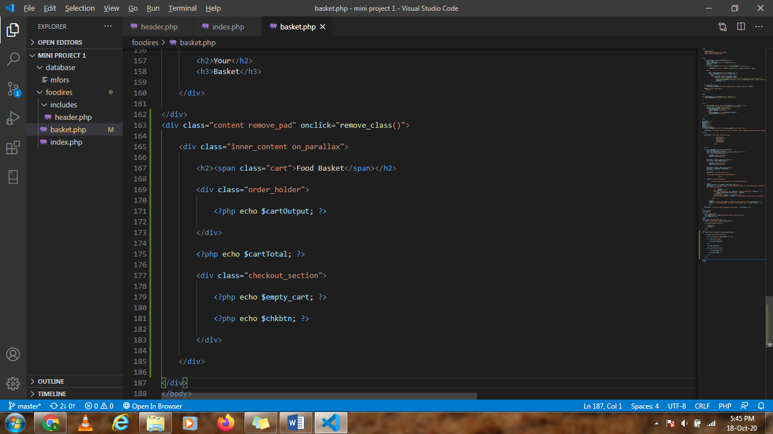

**References**

* <https://codepen.io/>
* <https://www.w3schools.com/>
* https://www.udemy.com/courses/